AM000-Asia-China-Han-Jade Openwork and Bronze

**Old China's Bronze hand made mirror "sishoujing" 四兽镜**

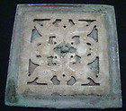

[Old China's Bronze hand made mirror "sishoujing" 四兽镜](http://www.ebay.com/itm/320907294136?ssPageName=STRK:MEWNX:IT&_trksid=p3984.m1439.l2649) (320907294136)

Sale date: 05/18/12

Tracking number: --

Estimated Delivery: 06/08/12 - 06/21/12

$119.99

Free

shipping

**Paid with PayPal on May 18, 2012.**